Specialty Sandwiches

1) The Casazza
Ham, salami, Prosciutto, Provolone & Italian dressing

2) Turkey Club Turkey, Bacon, Cheddar Cheese & Avocado

3) The River Cat
Turkey, Ham, Roast Beef & choice of cheese

4) The Big Slick
Hot Turkey, Cranberry & Cream Cheese

5) The Night Hawk
Chicken, Bacon, Avocado & choice of cheese

6) Roast Beef Bomb
Roast Beef, Bomb sauce & Cream Cheese

7) Pastrami Melt
Hot Pastrami & choice of cheese

8) Hot Chick
Chicken, Hot Sauce, Bomb Sauce & Pepper Jack Cheese

9) BBQ Beef
Hot Roast Beef, BBQ sauce & Jack Cheese

10) Garden Patch
Veggies, Avocado, Cucumber, Olives & choice of cheese

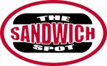

11) Chicken Lickin
Chicken, BBQ, Teriyaki, Bomb Sauce & choice of cheese

12) Da Big Brudda
Pastrami, Roast Beef, Salami & choice of cheese

13) Capital City Classic
Bacon, Lettuce, Tomato & Avocado

14) The Gateway Chicken, BBQ sauce & Jack Cheese

15) Heat Wave
Salami, Bomb sauce & Pepper Jack Cheese

16) Mikey Likes It
Turkey, Avocado, Bomb Sauce & Cream Cheese

17) The Phoenix
Chicken, Cranberry, American cheese

18) Sumo Chicken Chicken, Teriyaki & Jack Cheese
Add Pineapple .50

19) Cube Dweller Delight
Turkey, Prosciutto, Avocado & Swiss Cheese

20) Cheesy Pig & Cow
Roast Beef, BBQ Sauce, Bacon & Cheddar Cheese

21) Reuben
Hot Pastrami, Sauerkraut, Swiss cheese 1000 Island

22) Thai Breaker
Chicken, pineapple, pepper jack & sweet chili Thai sauce

Signature Sandwiches $8.49

Everything Includes:
Mayo, Mustard, Secret Sauce, Lettuce, Tomato, Pickles, Onions & Peppers

Basic Sandwiches

Choice of Meat: $7.49
Turkey Roast Beef
Ham Salami
Pastrami Tuna
Chicken Salad

Choice of Cheese: $0.50 cents
Swiss, Jack, Cheddar, Pepper Jack, Provolone, American, Ghost Pepper

Rolls: Dutch Crunch, Sourdough, Sweet, Wheat

Sliced Bread: sourdough, wheat, Rye
Extras
Bacon $.99
Avocado $.99
Cranberry $.99
Cream Cheese $.99
Bomb sauce $.50
Secret sauce $.50
Dressing $.50

Sides (½ pints)
Macaroni Salad $2.49
Potato Salad $2.49
Chips $1.35
COOKIES $1.65
Salads
Sm. Green Salad $3.49
Lg. Green Salad $5.49
Tuna or Chicken Salad $7.99
Chef’s Salad $7.99
Cobb Salad $8.50

Dressings: Ranch, Italian, 1000 Island, Blue cheese, Balsamic Vinaigrette, Fat Free Italian

Drinks
Cans or bottled water $1.49
Bottled Drinks $1.89

PARTY PLATTERS
AVAILABLE

Small platter
(6 sandwiches)
$54.99

Large platter
(8 sandwiches)
$69.99

Platter Choices
Ham
Pastrami
Roast Beef
Salami
Turkey
#1 The Casazza
#3 The River Cat
#10 Garden Patch

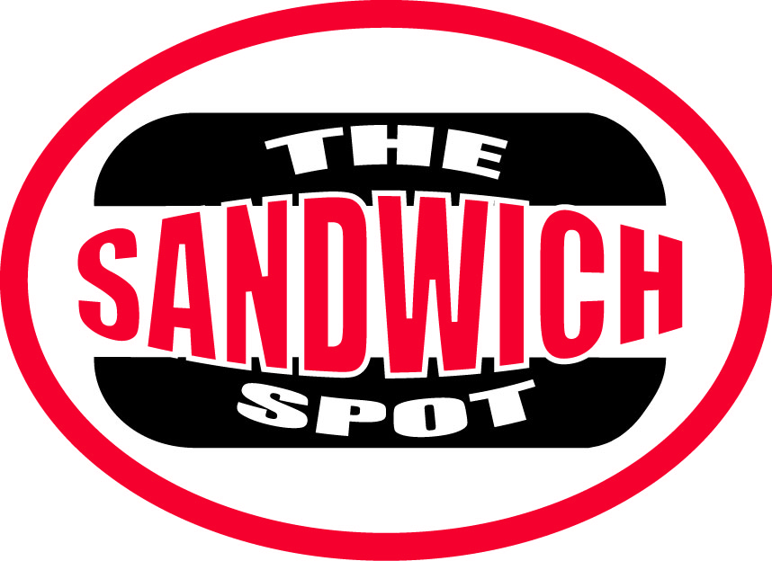

2606 GATEWAY OAKS DR.
SACRAMENTO, CA 95833

PHONE (916) 927-0188
Call in orders are welcome

BBQ TRI-TIP
TUESDAY & FRIDAY

HOURS OF OPERATION:
MONDAY- THURSDAY 10am - 5pm
FRIDAY 10am – 4pm
SATURDAY 11 – 4pm

Order online
www.thesandwichspot.com

