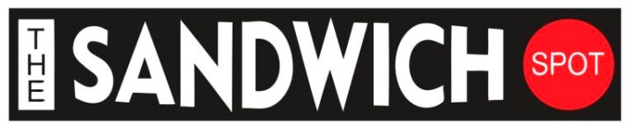
5301 Power Inn Road,
Sacramento, CA 95820
Phone: (916) 387-8643
Fax: (916) 387-8652

Hours: Monday-Friday 10:00am-4:00pm **ONLINE ORDER: www.thesandwichspot.com
Saturday 11:00am-3:00pm, Sunday Close **CALL ORDER: (916) 387-8643

"LOVE ALL" • "FEED ALL"

Sandwich Platters / Cookie Platter / Salad / Delivery

Free
Regular fountain Drink
With any sando purchase!
OFFER ONLY VALID AT POWER INN LOCATIONS THROUGH 07/31/2018!

**CALL US WE DELIVER**
Deliveries for five sandwiches or more or platter catering, please call by 10.00AM (Max 2 miles)

( Tri-Tip Special Monday & Wednesday $9.25 )
1) AVN Expo (cold sando) $8.99  Ham, Salami, Prosciutto, Provolone & Italian Dressing  2) Blue Man Group *** $8.99  Hot Turkey, Bacon, Cheddar Cheese & Avocado  3) Carrot Top Show (cold sando) **$8.99  Turkey, Ham, Roast Beef & choice of cheese  4) CES Expo $8.99  Hot Turkey, Cranberry & Cream Cheese  5) Chippendales *** $8.99  Marinated Chicken, Bacon, Avocado & choice of cheese  6) Coyote Ugly Club $8.99  Hot Roast Beef, Bomb Sauce & Cream Cheese  7) Criss Angel Believe $8.50  Hot Pastrami & choice of cheese  8) Divorce Party *** $8.50  Marinated Chicken, Spicy Bomb Sauce & Pepper Jack Cheese  9) Dixie’s Dam Bar $8.50  Hot Roast Beef, BBQ Sauce & Jack Cheese  10) Fantasty (cold sando) $7.50  Veggies, Avocado, Cucumber, Black olive & choice of cheese  11) Grace Land wedding Chapel $8.99  Chicken, BBQ, Teriyaki, Bomb sauce and choice of cheese  12) Hoover Dam *** $8.99  Hot Pastrami, Roast Beef, Salami & choice of cheese | 13) KA Le Soleil $8.50  Bacon, Lettuce, Tomato & Avocado  14) La Vegas Strip $8.50  Marinated Chicken, BBQ Sauce & Jack Cheese  15) Le Rerve Le Soleil $8.50  Hot Salami, Bomb Sauce & Pepper Jack Cheese  16) Marquee Night Club $8.99  Hot Turkey, Avocado, Bomb Sauce & Cream Cheese  17) Menopause The Musical $8.50  Marinated chicken, American Cheese, cranberry  18) Mystere Le Soleil $8.50  Marinated Chicken, Teriyaki & Jack Cheese  19) Sin City Comedy *** $8.99  Hot Turkey, Prosciutto, Avocado & Swiss Cheese  20) Sport Books $8.99  Roast Beef, Bacon, BBQ Sauce & Cheddar Cheese  21) Thunder from Down Under $8.50  Marinated Chicken, Hot Sauce, Blue Cheese Dressing & Pepper Jack Cheese  22) TAO Night Club $8.50  Pastrami, Sauerkraut, 1000 Island Dressing & Swiss Cheese  23) West Republic Club $8.50  Meatballs, Marinara Sauce & Provolone Cheese  24) WSOP Tourament $8.99 Chicken, Cranberry, Bomb Sauce & Pepper Jack Cheese

Rolls Bread: Dutch Crunch, Sourdough, Sweet & Wheat
Sliced Bread: Wheat. Rye and Sourdough
Choice of Cheese: Swiss, Jack, Cheddar, Pepper Jack, Provolone & American
Everything Includes: Mayo, Mustard, Secret Sauce, Lettuce, Tomato, Pickles, Onions & Peppers
Create Your Own Sandwich (cold sandos)
Choice of Meat: $7.99
Turkey Roast Beef
Ham Salami
Pastrami Prosciutto
Chicken Salad Tuna Salad

Choice of Cheese: $.50
Swiss, Jack, Cheddar, Pepper Jack, Provolone & American

Extras:
Bacon $1.25
Avocado $1.25
Cranberry/Choice of Chesses $.50
Cream Cheese/Pesto/Ghost pepper $.99
1/2Meat $1.99
Full Meat $3.99

Baked Good $1.79
Chocolate Cookie
Peanut Butter Cookie
Brownie

Sides (8oz)
Macaroni Salad $2.50
Potato Salad $2.50

Salads (Choice of 2 dressing)
Green Salad $4.99
Tuna or Chicken Salad $7.99
Chef’s Salad $7.99

Dressings: Ranch, Italian, Thousand islands, Blue cheese, Bomb Sauce, secret sauce and Balsamic.
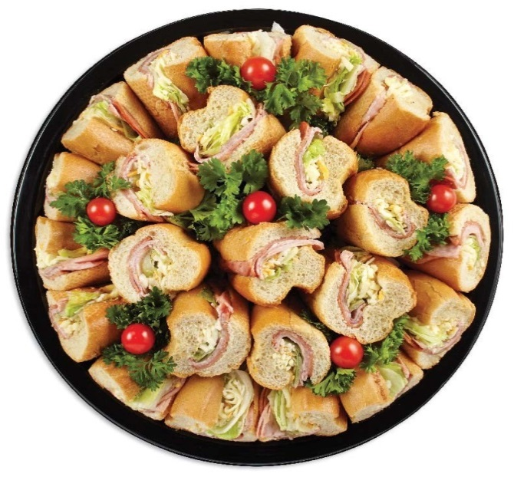
**Any Sandwich Can Be Made Into a Salad **

Catering
Sandwich Platters
$44.99 (6 Sandos cut and half, it feeds 12)
$59.99 (8 Sandos cut and half, it feeds 16)
Green Salad: $4.49/P (min 6 people)
Bakery Platter: $1.49/P (min 6 people)
Prices are subject to change without notice

